Cypress Elementary
Cub Accomplishments
March 2016

Golden Spatula Winners

The following students received a special lunch
experience! Every other Monday, we draw 10
tickets, and those lucky students will enjoy a
special celebration with a buddy, Mrs. Krapfl
and Mrs. Tonello on Thursday! Students
can earn a Golden Spatula Ticket by showing
outstanding behavior and manners in the
Cafeteria.

February 8 February 22
Nacere Lewis Madison McGovern
Logan Howard Mia Terito
Delanie Sand RJ Carter
Sophia Vasquez Matthew Gilliam
Sofi Laman Cayden Zerr
Cole Crabtree Victoria Yovanovich
Alli Poll Daisy Stroup
Jayden Overton Dyxee Avelares
Spencer Clary Ellie Wilson
*Apologies to Emilia Melgar-Townson
for previous misspelling of name

Bus Students of the Week

Cody Ramsey, Annabell Martin, Audrey Delucco,
Paul Wydzierzecki, Trey Handelong,
Piper Langlais, Kush Patel, Chloe Green,
Sam Cheek, Tyler Vincent, Bailey Wooters,
Gavin Wilson, Eric Kersey, Jayden Thornton,
Owen Wilson, Andrew Armstead

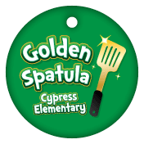
Mile Marker Time!!

1. Luke Tremmel
2. Mia Terito
3. Branden Jenkins
4. Logan Howard
5. Moksh Patel
6. Nick Smith
7. Javan Baggott
8. Lydia Raybould
9. Nick Zakrzewski
10. Nathan Merritt
11. Hansen Smith
12. Jack Sutherlin
13. C.J. Macomber
14. Logan Miramonti
15. Jude Jenkins
16. Brady Burke
17. Connor Chester
18. Julius Quinones
19. Noah St. Aubin
20. Nick Clohessy
21. Abby Vanasco
22. Kyndal Mannion

23. Christian Rains
24. Ashton Adams
25. Xoey Lyons
26. Kylie Clune
27. Nathan Nikel
28. Jacob Shaver
29. Kyler Wiltshire
30. Joseph Harris
31. Noah Benjamin
32. Gavin Nelson
33. Samantha Morrow
34. Ethan Culbertson
35. Sarah Frazer
36. Savannah Stahl
37. Camden St. Aubin
38. Zachary Stubblefield
39. Evan Serrano
40. Emma Bell
41. Allison Poll
42. Cole Wilson
43. Braden Cook (Cookie)
44. Zack Van Dielen
45. Noah Blevins
46. Noah Combs
47. Garrett Madden
48. Michael Beardi
49. Jase Deighton
50. Jake Schwartz
51. Ryan St. Denis
52. Cooper Gibson
53. Kayleigh Gibson
54. Sierra Paquette
55. Aiden Sipple
56. Rylee Rodriguez
57. Connor Harrison
58. Sam Cheek
59. Dwight Clemons
60. Jeremiah Hitchcock
61. Madison McGovern
62. Theresa Boban
63. Aundreyas Bonner
64. Charley Brown
65. Kiran Joseph
66. Julie Terito
67. Caleb Taylor
68. Cole Hawks
69. Stavros Demopoulos
70. Hadley Hart
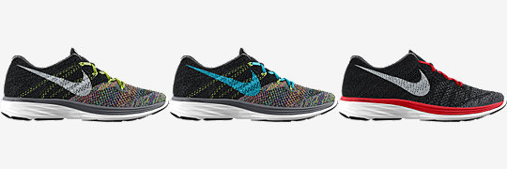
71. Rebecca Morales
72. Hayden Danielson
73. Alex Cortier
74. Kika Jibawi
75. Ethan Mehring
76. Marcus Scheiderer
77. Jeremiah Hitchcock
78. Aiden Palmer
79. Colton Korby
80. Sofi Laman
81. Danica Federle
82. Lilly Stith
83. Rachel Golnik
84. Alyssa West
85. Bryce Paul

First runner to 40 miles:
Mia Terito!!!

February Student of the Month

Riley Bowman – Mrs. Cossaboon
Kinsley DeGroat – Ms. Bevan
Hayden Dickerson – Mrs. Davis
Cooper Gibson – Ms. Blanks
Austin Scharlow – Ms. Sampson
Elliana Wilson – Mrs. Bonacasa
Holley Brown – Ms. Pangburn
Michael Carter – Mrs. VanOchten
Danica Federle – Mrs. Gildard
Sofiana Laman – Mrs. Ochs
Joyce Lockbaum – Mrs. Hinson
Sahara Martin – Mrs. Lees
Joseph Pacimeo – Mrs. Duffy
Jacob Curry – Mrs. Perez
P.J. Drougas – Mrs. Stanley
Abby Farally – Mrs. Richards
Annabella Hitchcock - Mrs. Quina
James Pettingill – Mrs. Sowash
Olivia Soulounias – Mrs. Adams
Dean Walters – Mrs. Mehring
Charley Brown – Mrs. Herny
Christine Burnette – Mr. Krispin
Isabella Housel – Mrs. Sikalos
Olivia Negron – Mrs. Brissey
Logan Pitts – Mrs. Clune
Riley Thompson – Mrs. Burchard
Damian Dunn – Mrs. Jen Miller
Richard House – Mrs. Watkinson
Mariah Piszczek – Mrs. Johns
Tessa Soltis – Mrs. Taylor
Tyler Vincent – Mrs. Judy Miller
Marissah Brydon – Mrs. Campo
Madison Campbell – Mrs. Hawks
Spencer Clary – Mrs. Rodriguez
Sam Deberry – Mrs. Scheu
Cory Mahoney – Ms. Crabtree
Dalen Ragsdale – Mrs. Poll
Jayden Thornton – Ms. Robinson

Jacquelyn Hoffman-Liptak – Mrs. Fluke Joseph Kelly – Ms. McKone and Mrs. Trumble
Bailey Wooters – Ms. Ferris, Ms. Val, Ms. Amy and Ms. Jodi

Logging Minutes
Whether you are logging your minutes at home, at school, or if your teacher is doing it for you, our minutes are
adding up! The goal for all our students is to be able to log their minutes independently. How is your child
logging minutes? Please do not forget to include the AT SCHOOL MINUTES, ALSO!

Total minutes logged, school-wide as of 1/27/16 is 1,695,999.
286 Students have reached the 2000 minute white milestone 12 Students have reached the 10,000 minute red milestone
133 Students have reached the 4000 minute green milestone 4 Students have reached 12,000 minute blue milestone
67 Students have reached the 6000 minute yellow milestone 2 Student reached the 15,000 minute orange milestone
33 Students have reached the 8,000 minute purple milestone
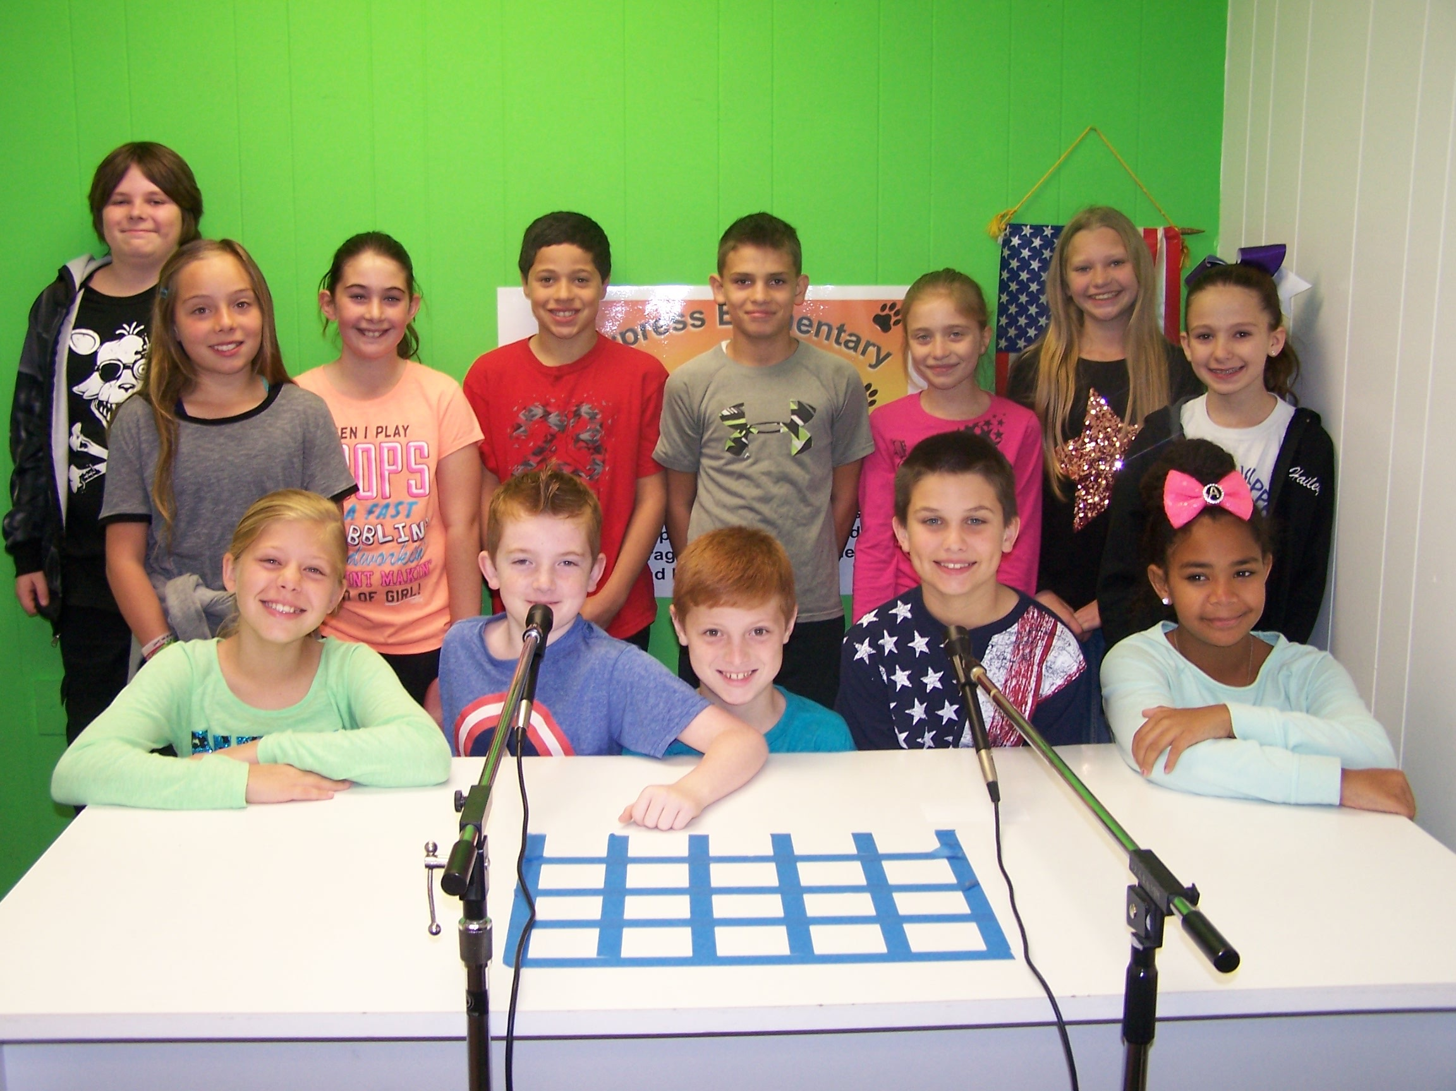

Fantastic job Cypress News Crew!

Has a staff member at Cypress Elementary gone above and beyond for you, your child, or family?

If so, please take a few minutes to fill out this form, and send the form back to the school so that the administration can convey this recognition to that special person.
We would love to hear from you! ___________________________________
(name of person you wish to recognize)
Your name___________________________
Your Child’s (children’s) names (s)______________________________________
Your child’s (children’s) names (s)______________________________________
What did the person you wish to recognize do to exceed your expectations?:

______________________________________________________________

