Cypress Elementary
Cub Accomplishments
June 2016

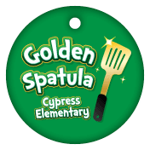
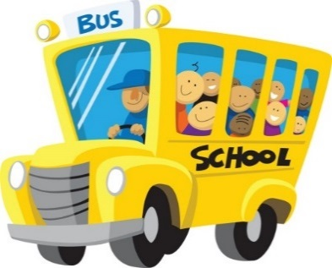
Bus Students of the Week
Jada Treesh, Daisy Stroup, Sama Haggag, Eshan Tahir, Malachi Small, Xoey Lyons, CJ Figueroa, Tyler Belcher, Blake Tuttle, Jacob Shaver, Andrew Wojdac, James Pettingill, Isiah Urrutia,
Taylor Edwards, Maggie Nappier, Kristen Towner,
Annabelle Serrano, Thomas Lawrence,
Devin Butler, Charles Deitz, Jeremiah Hitchcock,
Christina Burnett, Charler Deitz

Congratulation to Bus 272 for
Earning a Bus Mystery Prize!

Golden Spatula Winners
Every other Monday, we draw 10 tickets, and those lucky students will enjoy a special celebration with a buddy, Mrs. Graziaplene and Mrs. Tonello on Thursday! Students can earn a Golden Spatula Ticket by showing outstanding behavior and manners in the Cafeteria.
May 1 May 16
Lexi Viars Mia Hunt
Victoria Littleton Mia Terito
Kadence Stiles Nacere Lewis
Sheree Posey Jacob Collins
Chandler Mundi Jayden Overton
Kaja Dymecka Gage Kersey
Samantha Wang Christos Papapanos
Kaylee Hauck Jeremiah
Emilia Melgar-Townson Kailyn
Lena Jernigan Cidenn Wise

Pasco County Water Awareness Poster Contest
Congratulations go to Mrs. Van Ochten for entering her students in the Pasco Water Awareness Poster Contest! In the First Grade Devision, Emma Bell received First Place and Gavin Lowe received Second Place!

Paws for Reading
Whether you are logging your minutes at home, at school, or if your teacher is doing it for you, our minutes
are adding up! The goal for all our students is to be able to log their minutes independently. How is your
child logging minutes? Please do not forget to include the AT SCHOOL MINUTES, ALSO!

Total minutes logged, school-wide as of 4/22/16 is 2,242,210!
364 Students have reached the 2000 minute white milestone 67 Students have reached the 10,000 minute red milestone
256 Students have reached the 4000 minute green milestone 35 Students have reached 12,000 minute blue milestone
173 Students have reached the 6000 minute yellow milestone 15 Student reached the 15,000 minute orange milestone
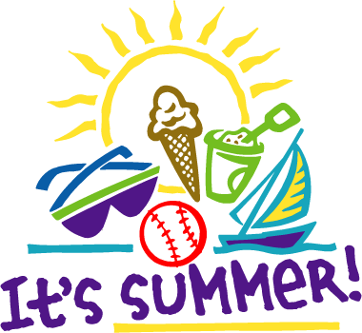
124 Students have reached the 8,000 minute purple milestone 4 Student reached 25,000+ minute rainbow milestone

Have a fun, safe Summer Break!

