Cypress Elementary Community Tracks

May 2016
Tracy Graziaplene Erika Tonello
Principal Debbie Burd Assistant Principal
Community Involvement Coordinator tweet @CypressTonello
(727) 774-4500 dburd@pasco.k12.fl.us

Cypress Elementary is more than a building with students and teachers. Cypress is a community. A community involved WITH our students FOR our students.
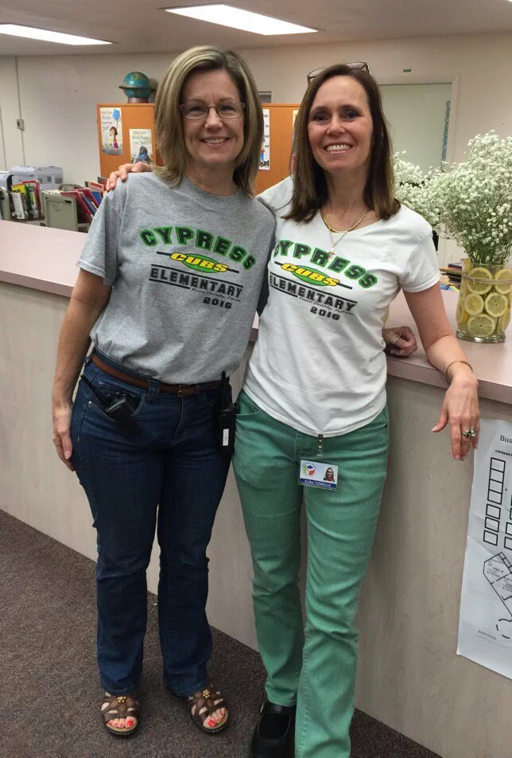
Welcome Mrs. Graziaplene!

Publix Mother’s Day Cakes
We still have some cakes available for purchase for $8. Cakes will be
decorated on Thursday, May 5th. If you have any questions, please
call the school office at 727-774-4500.

Community Involvement

Adopt-A-Class
We are pleased to support our teachers by facilitating the Adopt-
A-Class Program. For a complete listing of our Adopt-A-Class
Participants, please visit our Cypress Web Page. If you are
interested in adopting a class, please call our front office.
Lisa Harper adopted Mrs. Poll’s class

Community Partners
Cypress Banner Program
Want a great advertising value? Check out our Banner Program! For $200 we will display your banner on the recess fence! Contact Debbie Burd for more information!

We thank the following businesses and organizations for partnering with Cypress.

Cypress School Rewards ID: 70088866

Business Partners
We are truly grateful for all the support we receive from our Cypress community! Without the donation of volunteer time, goods/services, and of course financial donations, many of our programs would not be as successful.
2015-16 Business Partners: Riverwalk Publix, McDonald’s (Jose Hernandez/HMCC MGMT. Corp), Beef ‘O’ Brady’s, Inn on the Gulf, Astro Skate, Regis Lima Martial Arts, All Sports Arena, Culver’s, and Mama Mia Pizzeria
Family Involvement
“At the end of the day, the most overwhelming key to a child’s success is the positive involvement of parents”
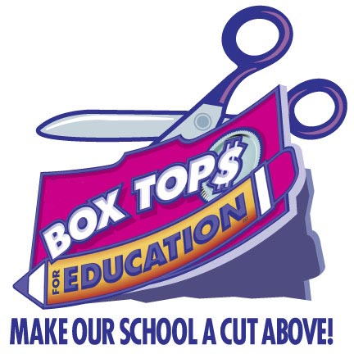
–Jane D. Hall

Cypress PTO
Are you a planner? Are you a leader? We need you!!

It's that time of year where we are wrapping things up, planning for the school year next year, and we have 3 open positions in PTO. If you want to be more involved with our school, have the time to put into organizing and putting together functions, then please join us on May 4th in the Media at 4:15. We are looking forward to seeing you there!
Recycling items that can go in the Recycling Dumpster: Brown paper
bags, cardboard, cereal boxes, construction paper, gift wrap, magazines,
newspaper, paper, and phone books may be placed loosely in a
participating school’s GreenFiber recycling container. Please do not
place glass, metal, plastic bottles, plastic bags, aluminum, string, or
foam in the GreenFiber recycling container. Gates open 6 am – 6 pm

---Yearbooks are still for Sale!! $15 While supplies last!---
