**Cypress Elementary Community Tracks**



**June 2016**

**Tracy Graziaplene Erika Tonello**

**Principal Debbie Burd Assistant Principal**

**Community Involvement Coordinator tweet @CypressTonello**

**(727) 774-4500 dburd@pasco.k12.fl.us**

Cypress Elementary is more than a building with students and teachers. Cypress is a community. A community involved WITH our students FOR our students.

Cypress Families, this has been a great year. We have made a lot of memories, made a lot of new friends and above all, made some great learning gains.

Over the summer, you can visit our Cypress Webpage (ces.pasco.k12.fl.us) for information regarding Meet the Teacher, Supply Lists, and other information for the upcoming school year.

Scholastic Summer Reading Challenge is available! If you would like your child to stay in the habit of logging the reading minutes, please email Debbie Burd ([dburd@pasco.k12.fl.us](mailto:dburd@pasco.k12.fl.us)). You will be set up with a username and password that is attached to Cypress Elementary.

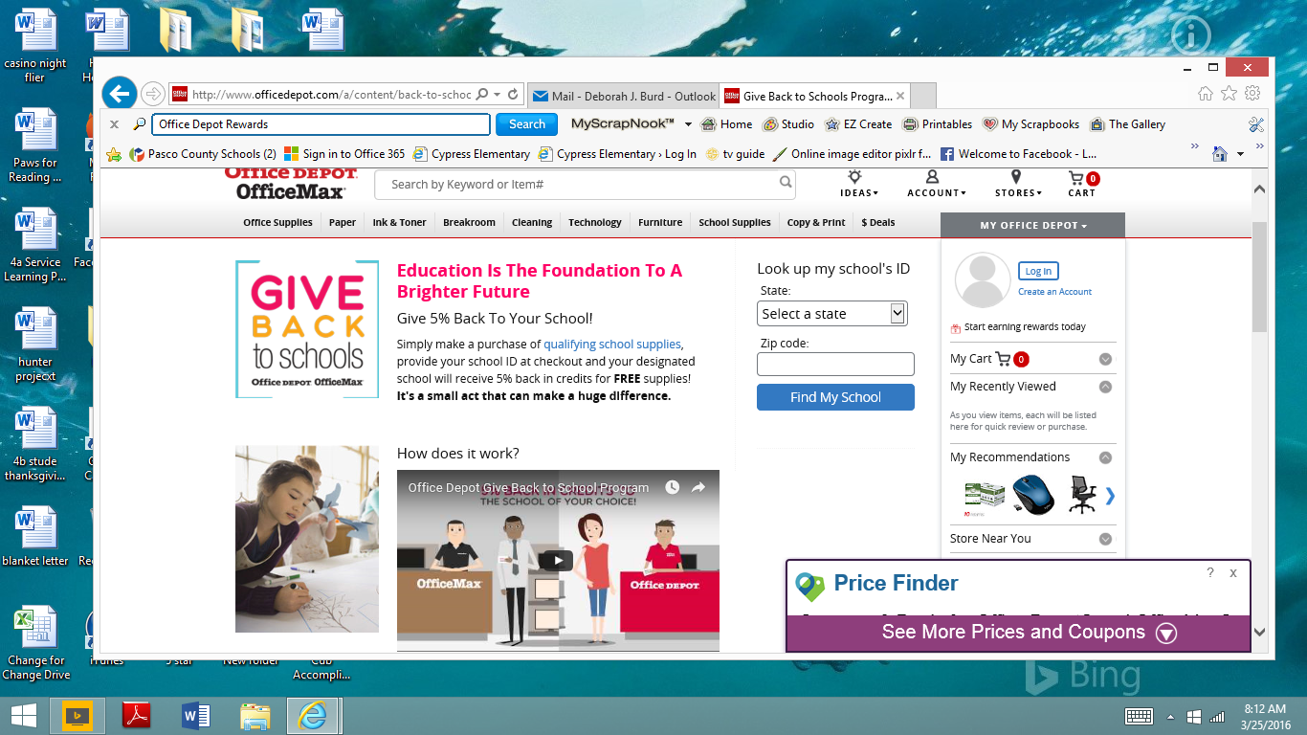 **Community Partners**

**Cypress Banner Program**

Want a great advertising value? Check out our Banner Program! For $200 we will display your banner on the recess fence! Contact Debbie Burd for more information!

 **Cypress School Rewards ID: 70088866**



**Business Partners**

We are truly grateful for all the support we receive from our Cypress community! Without the donation of volunteer time, goods/services, and of course financial donations, many of our programs would not be as successful.

2015-16 Business Partners: Riverwalk Publix, McDonald’s (Jose Hernandez/HMCC MGMT. Corp), Beef ‘O’ Brady’s, Inn on the Gulf, Astro Skate, Regis Lima Martial Arts, All Sports Arena, Culver’s, and Mama Mia Pizzeria

**Family Involvement**

**“At the end of the day, the most overwhelming key to a child’s success is the positive involvement of parents”**

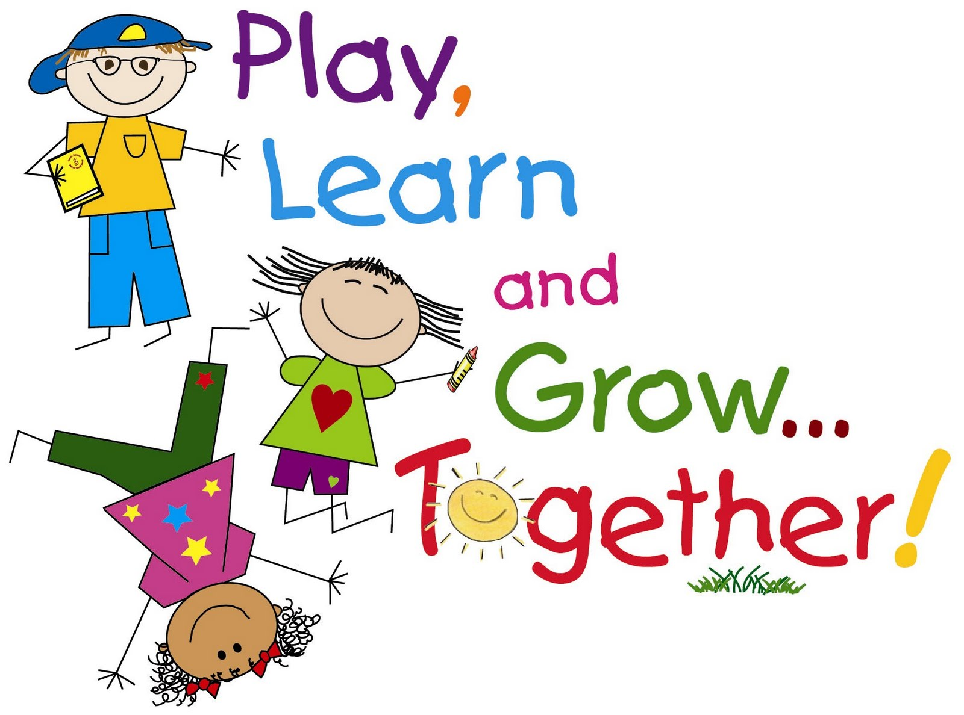[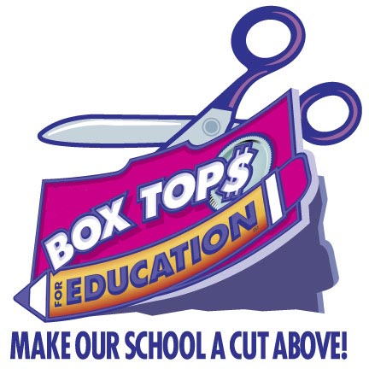](http://www.google.com/url?sa=i&rct=j&q=&esrc=s&source=images&cd=&cad=rja&uact=8&ved=0ahUKEwiFpdfMj9DJAhWEwiYKHck9Dc0QjRwIBw&url=http://armatage.mpls.k12.mn.us/box_tops_ed&psig=AFQjCNEkAdW8m9sqEEO0dIxpiRZ7y_Bw2A&ust=1449796587135313) **–Jane D. Hall**

**KEEP SAVING YOUR BOX TOPS!!!**

**Cypress Volunteers & Cypress PTO**

Next year we will be looking to build a phenomenal Volunteer Program as

Well as a strong PTO. We encourage all Cypress parents to take a few moments to contemplate how you would like to involved next year.

Volunteers are always needed to help with day to day project prep, clerical and extra hands in the classrooms. If you have a new Kindergartener, we will tell you that we like to give it a few weeks to allow your students to get comfortable in the school routine before volunteering IN the classroom.

For all volunteers, whether new to the school or returning, we will encourage you to step up and help with our Read to Me Students. These students will need 500 books read to them the first 30 days of school.

For parents that would like to be MORE involved than a regular volunteer, we invite you to join our PTO. Cypress PTO is responsible for planning many school events. You DO NOT HAVE TO BE A VOLUNTEER TO BE PTO ACTIVE. If you are PTO active during the school day, on campus, then you do need to be an approved volunteer.

Volunteer Applications for the upcoming school year can be submitted online after JULY 1st. Please email Debbie Burd ([dburd@pasco.k12.fl.us](mailto:dburd@pasco.k12.fl.us)) after submitting your application, so it can get approved. Remember, they are not automatically approved.



Recycling items that can go in the Recycling Dumpster: Brown paper

bags, cardboard, cereal boxes, construction paper, gift wrap, magazines,

newspaper, paper, and phone books may be placed loosely in a

participating school’s GreenFiber recycling container. Please do not

place glass, metal, plastic bottles, plastic bags, aluminum, string, or

foam in the GreenFiber recycling container. **Gates open 6 am – 6 pm**