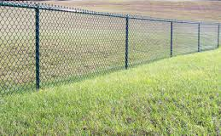
+ + =
Your
Banner
Our Playground Fence
Your
$200
+
Fundraising for Student Incentives & Family Involvement Programs
Cheap and Effective Advertising Dollars

Cypress Is pleased to offer a banner program for members of our community who would like to advertise at our school. You supply the banner, and we will hang it on our Playground Fence. This is a win-win for our students, who benefit with the monies raised. This is a win-win for the business, which gets the advertising they wish.

For a flat rate of $200 we will display the banner for the school year. Your banner will be seen by every car coming into the parking lot (parents, visitors, vendors) daily as well as after-school functions.

If you are interested in participating, please complete the following information and return to the school office.

For questions, please contact Debbie Burd, Community Involvement Coordinator at 727-774-4500 dburd@pasco.k12.fl.us . This form is also available on the school website at ces.pasco.k12.fl.us .

____Yes, I want to display a banner for $200!

Business Name: _________________________________________________________________________________

Contact Name: _______________________________________________________________________________

Telephone: ____________________________________________________________________________________

Email: __________________________________________________________________________________________

