Cypress Elementary Community Tracks
September 2015
Jeanne Krapfl Erika Tonello
Principal Debbie Burd Assistant Principal
tweet @jlkrapfl Community Involvement Coordinator tweet @CypressTonello
(727) 774-4500 dburd@pasco.k12.fl.us

Cypress Elementary is more than a building with students and teachers. Cypress is a community. A community involved WITH our students FOR our students.

Family Involvement
“At the end of the day, the most overwhelming key to a child’s success is the positive involvement of parents” –Jane D. Hall

Staying in the Know!
One of the easiest ways to encourage your student’s success is to be informed to what is happening in the classroom, as well as school programs and activities. You have many ways to get school wide information:
- Our school webpage is ces.pasco.k12.fl
- Twitter accounts: @jlkrapfl
@cypressTonello
- Facebook site is Cypress Elementary Cubs (look for our cubbie)
- Mrs. Krapfl’s Sunday Calls (to your primary phone number)
- Pasco County School SMS text messaging (text the word JOIN to the number 56360)
- Fliers distributed in backpacks (CHECK YOUR CHILD’S BACKPACK WEEKLY!)
To keep up to date with teachers, many offer a webpage, twitter, class dojo, emails, class newsletters and text notifications.
Recycling items that can go in the Recycling Dumpster: Brown paper
bags, cardboard, cereal boxes, construction paper, gift wrap, magazines,
newspaper, paper, and phone books may be placed loosely in a
participating school’s GreenFiber recycling container. Please do not
place glass, metal, plastic bottles, plastic bags, aluminum, string, or
foam in the GreenFiber recycling container. Gates open 6am – 6 pm

All Pro Dad
We are pleased to introduce Mr. Bryan Callegari leading our group this year, kicking things off with a cook-out and a
dads vs. kids basketball game on
Monday, August 31, 4:30-6:00 pm.

Next All pro Dad meeting: 9/28(time TBA)

Volunteers
If you are interested in volunteering, please visit our school web page>Parents>Volunteer for all you need to know about volunteering, including a link to complete a volunteer application.

Your newest Cypress Cubs are our first priority this year! We have several students who need 500 books read to them in the first 30 days of school. The Kindergarten teachers have books ready and waiting on volunteers to stop by and read! Contact the Volunteer Coordinator for more details.

Cypress Banner Program
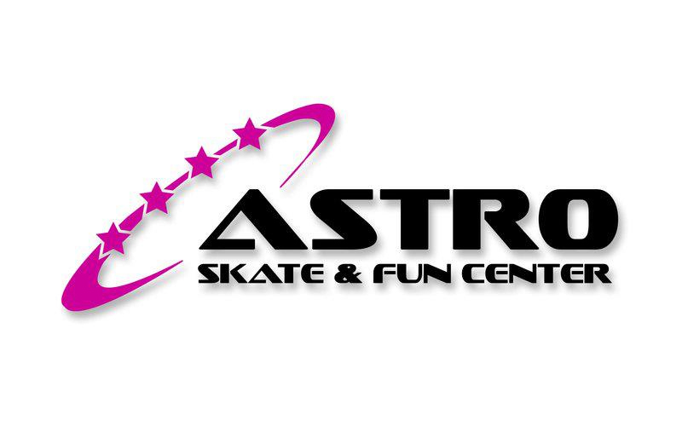
Want a great advertising value? Check out our Banner Program! For $200 we will display your banner on the recess fence! Contact Debbie Burd for more information!

Astro Skate
Our first Astro Skate Night is Wednesday, September 23. $10 per child and $10 per child includes bus ride, admission and basic skate rental! Participants leave Cypress at dismissal time and arrive back at Cypress for pick up at 7:00pm.

Community Involvement
Thank you to the following community members for partnering with Cypress: The Elks Lodge #2284 for donating much needed school supplies!

Adopt A Class
We are pleased to support our teachers by facilitating the Adopt A Class Program. The following families/businesses have sponsored a teacher/special area at Cypress by donating $100-$150.

Mrs. Cossaboon’s Class has been adopted in “Memory of Frances Nolan”
Forensic Technology adopted Mrs. Sowash’s Class
The Harrison Family adopted Mrs. Ochs’ Class
Kathy Jasmin Adopted Mrs. Bonacasa’s Class
Lynn Devine adopted Mrs. Mehring’s Class
The Laman Family adopted Mrs. Ochs’ Class

Business Partners
We are truly grateful for all the support we receive from our Cypress community! Through the donation of volunteer time, goods/services, and of course financial donations, many of our programs would not be as successful.
2014-2015 Business Partners
Riverwalk Publix, McDonald’s (Jose Hernandez/HMCC MGMT. Corp), Beef ‘O’ Brady’s, Inn on the Gulf, Astro
Skate, and Regis Lima Martial Arts.

NOTIFICATION OF INSPECTION FOR ASBESTOS CONTAINING MATERIALS IN PUBLIC SCHOOLS

The Environmental Protection Agency (EPA) has issued a final rule, 40 CFR Part 763, Asbestos Containing Material in schools, commonly referred to as AHERA. This rule requires all Local Education Agencies (LEA’s) to identify asbestos containing materials (ACM) in their school buildings and to take appropriate actions to control the release of asbestos fibers.

All inspections for Cypress Elementary have been completed and a Management Plan describing the results of the inspection and the action plan to control any asbestos found during the inspection, where applicable, has been submitted to the governor for approval. A copy of this plan is located in the administrative office of this school and at the Pasco County Schools Maintenance & Facility Services Department and is available for review upon request.

