Cypress Elementary Community Tracks
March 2016
Jeanne Krapfl Erika Tonello
Principal Debbie Burd Assistant Principal
tweet @jlkrapfl Community Involvement Coordinator tweet @CypressTonello
(727) 774-4500 dburd@pasco.k12.fl.us

Cypress Elementary is more than a building with students and teachers. Cypress is a community. A community involved WITH our students FOR our students.

Community Involvement

Adopt A Class
We are pleased to support our teachers by facilitating the Adopt A Class Program. For a complete listing of our Adopt-A-Class Participants, please visit our Cypress Web Page. If you are interested in adopting a class, please contact our front office.
Rio Salon Spa and Massage adopted Mrs. Van Ochten’s Class.

Cypress Banner Program
Want a great advertising value? Check out our Banner Program! For $200 we will display your banner on the recess fence! Contact Debbie Burd for more information!

Community Partners
We thank the following businesses and organizations for partnering with Cypress. Barbara Sharp for the donation of some warm wool blankets!
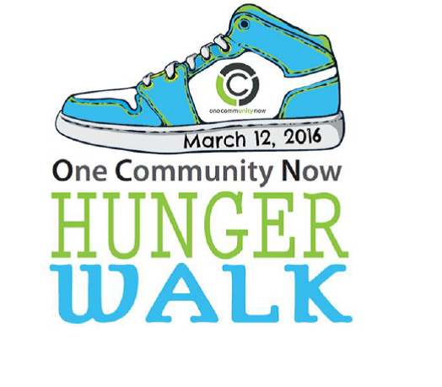

Cypress Elementary
Change for Change Drive

We are proud to announce we have
Collected over $600 so far! Keep bringing in your change to help the needy of Pasco County!

Business Partners
We are truly grateful for all the support we receive from our Cypress community! Without the donation of volunteer time, goods/services, and of course financial donations, many of our programs would not be as successful.
2015-16 Business Partners: Riverwalk Publix, McDonald’s (Jose Hernandez/HMCC MGMT. Corp), Beef ‘O’ Brady’s, Inn on the Gulf, Astro Skate, Regis Lima Martial Arts, All Sports Arena, Culver’s, and Mama Mia Pizzeria.
Thank you Mama Mia for the generous donation of 25 Pizza’s for our On-Track Student Celebration!

Family Involvement
“At the end of the day, the most overwhelming key to a child’s success is the positive involvement of parents”
–Jane D. Hall

With wonderful weather, it is a great time to get outside and enjoy some family time!! Just a few suggestions! Fliers for the first two went home last week!

March 12 9 am – noon: Hunger Walk at Gulf High School
March 12 2 pm – 5 pm: Community Spring Fling at River Ridge High School
Cypress Artwork On Display!
February 19 to April 3
600 Klosterman Road in Tarpon Springs

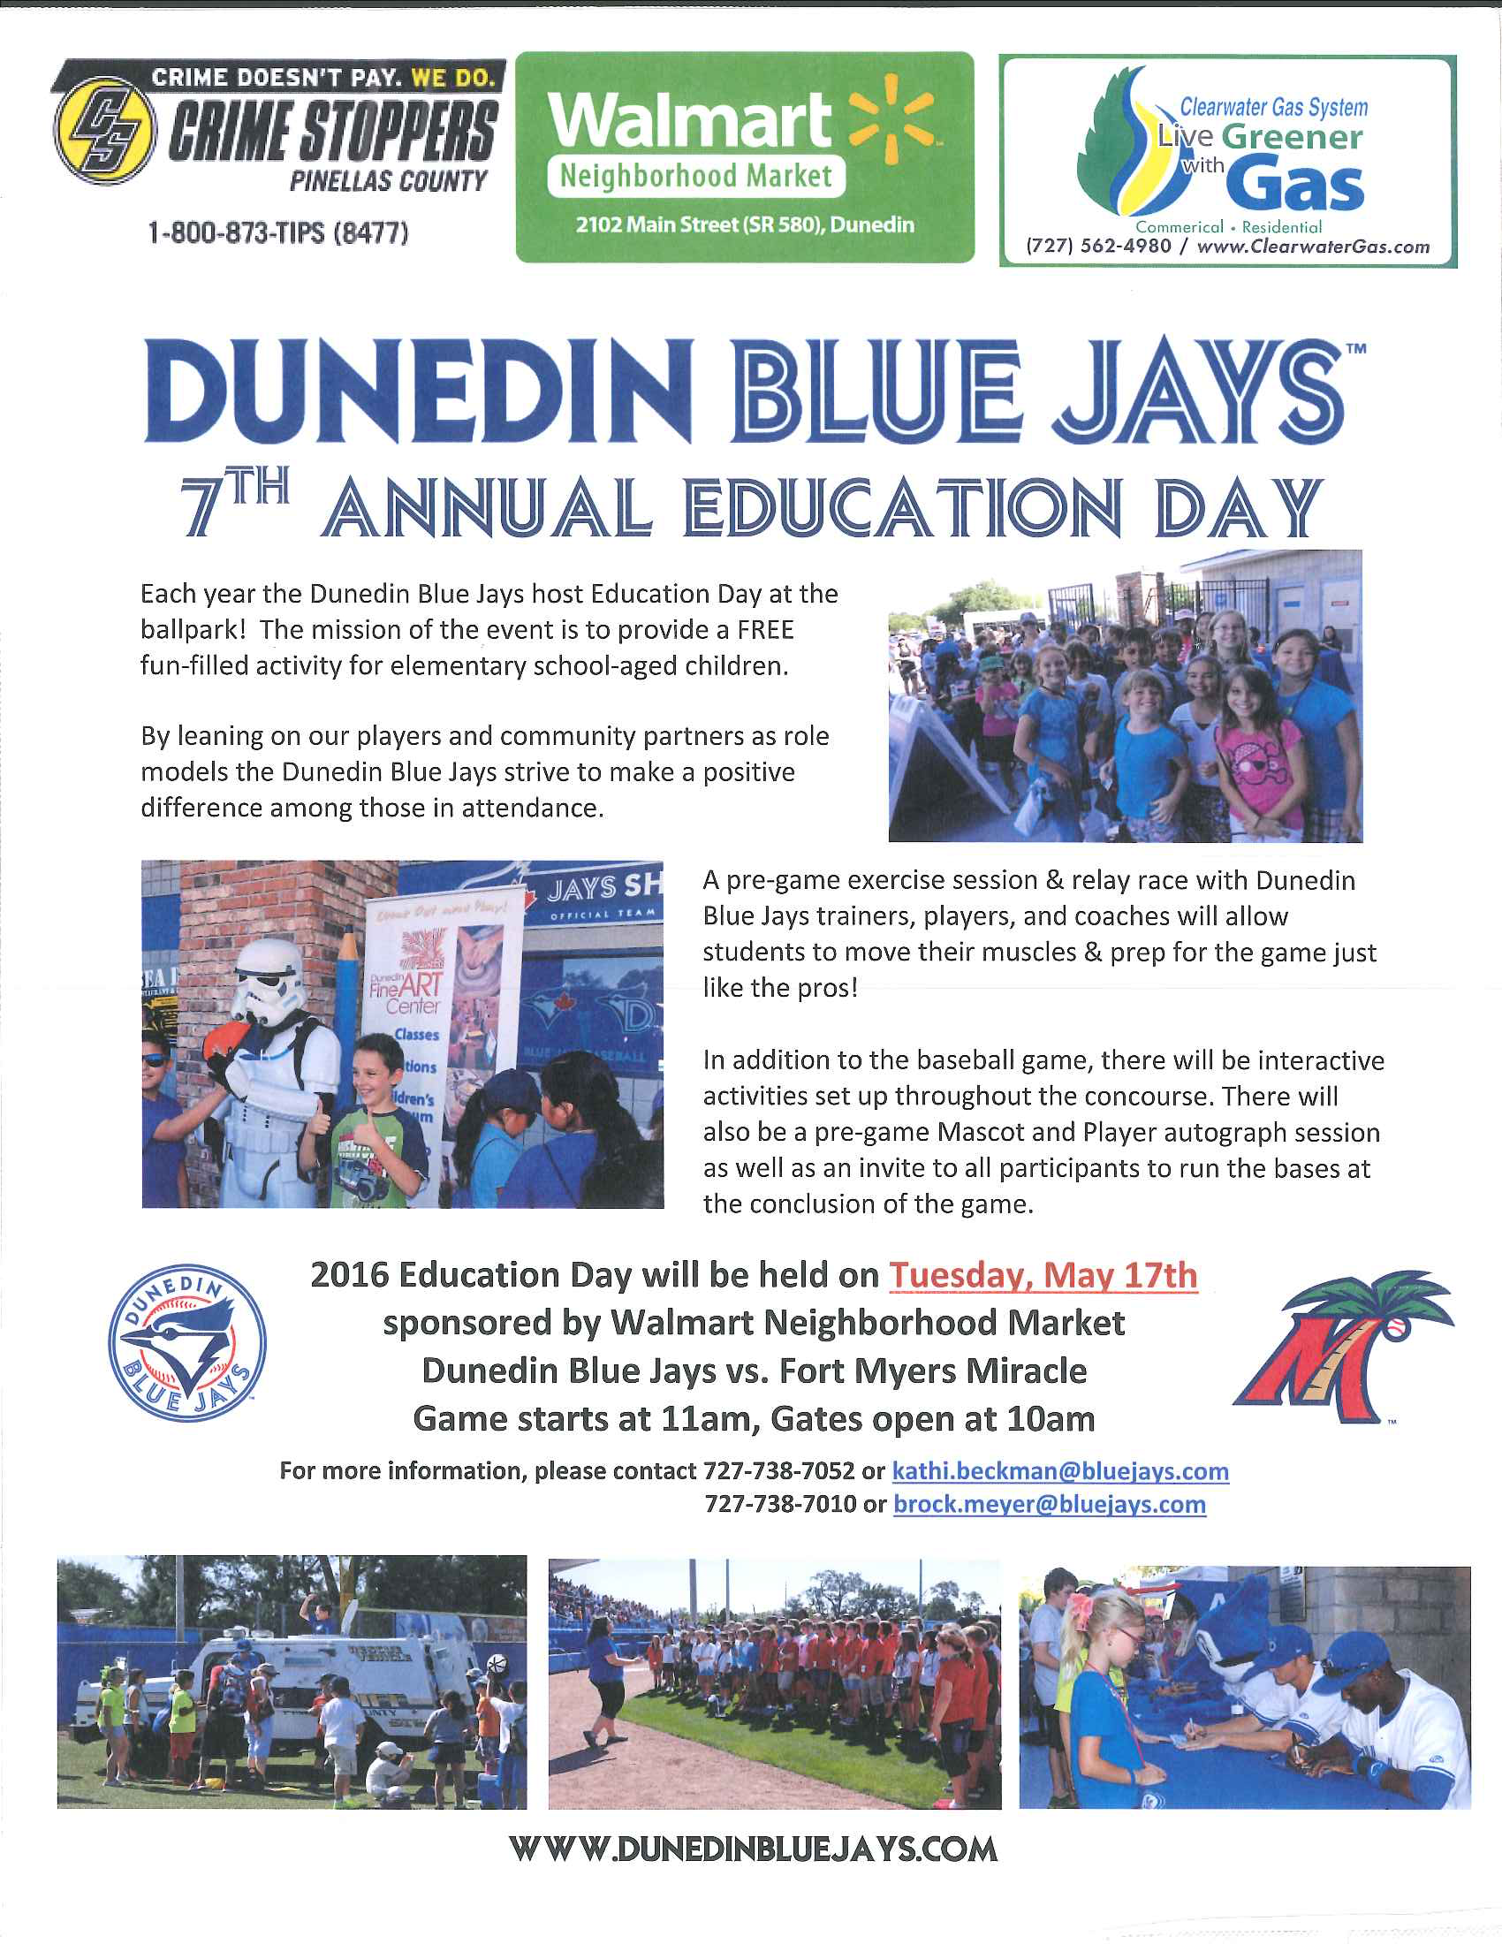
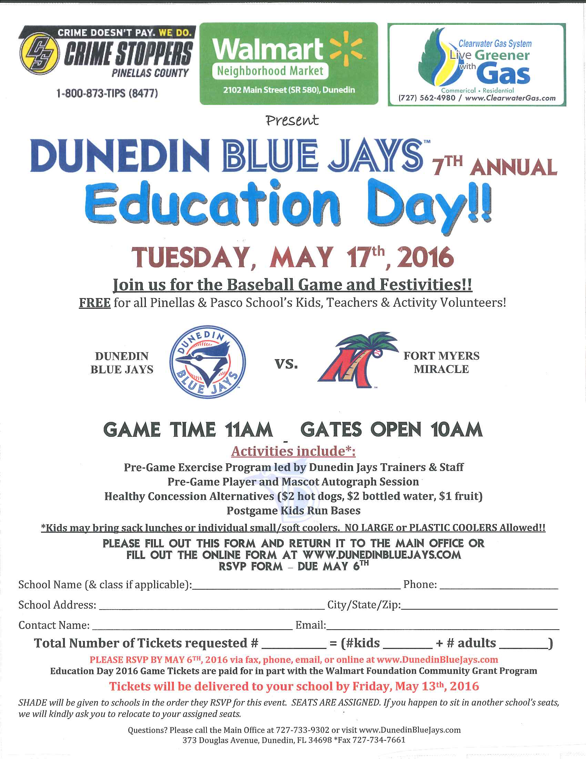

Dunedin Blue Jays Education Day Order forms are available in the School Office!

Recycling items that can go in the Recycling Dumpster: Brown paper
bags, cardboard, cereal boxes, construction paper, gift wrap, magazines,
newspaper, paper, and phone books may be placed loosely in a
participating school’s GreenFiber recycling container. Please do not
place glass, metal, plastic bottles, plastic bags, aluminum, string, or
foam in the GreenFiber recycling container. Gates open 6 am – 6 pm

