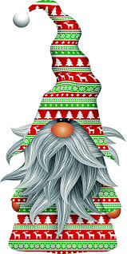
School Spirit Days
Let’s have some fun celebrating the Holidays!
Monday  December 14 | Grinch, Elf, or Holiday Gnome Day  Whether you prefer the Grinch, Cindy Lou or Max. Elf on the  Shelf, Buddy, or Hermy. This could also be the day to sport a  great big gnome beard!
Tuesday  December 15 | Holiday Theme Day  Santa Hats, reindeer antlers, Christmas trees,  snowman, or anything holiday. We can’t wait to  see our campus filled with holiday cheer!
Wednesday  December 16 | 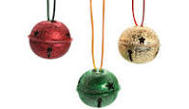  Red, Green and Jingle Day  Proudly wear red. Or green. Or red AND green.  Pop in a little jingle and you are ready for the day!
Thursday  December 17 | 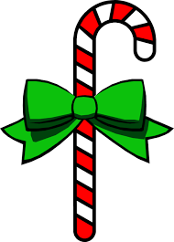  Holiday T-Shirt Day  This is the day for your favorite holiday t-shirt!
Friday  December 18 | 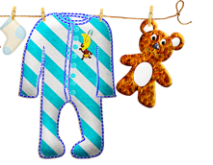  Pajama or Ugly Sweater Day and Holiday Socks  Ugly sweaters are always a favorite! Or your comfy  pajamas (school appropriate, please) for a relaxing  day before Winter Break.

School Spirit Days
Let’s have some fun celebrating the Holidays!
Monday  December 14 | Grinch, Elf, or Holiday Gnome Day  Whether you prefer the Grinch, Cindy Lou or Max. Elf on the  Shelf, Buddy, or Hermy. This could also be the day to sport a  great big gnome beard!
Tuesday  December 15 | Holiday Theme Day  Santa Hats, reindeer antlers, Christmas trees,  snowman, or anything holiday. We can’t wait to  see our campus filled with holiday cheer!
Wednesday  December 16 | Red, Green and Jingle Day  Proudly wear red. Or green. Or red AND green.  Pop in a little jingle and you are ready for the day!
Thursday  December 17 | Holiday T-Shirt Day  This is the day for your favorite holiday t-shirt!
Friday  December 18 | Pajama or Ugly Sweater Day and Holiday Socks  Ugly sweaters are always a favorite! Or your comfy  pajamas (school appropriate, please) for a relaxing  day before Winter Break.

