Please follow the directions below for morning drop off and afternoon pick-up:

1. Drop off and pick up times are 9:30AM and 3:50PM

2. Please follow the map- cars must stay in the right lane of the loop. Please stay in the line of cars and follow them through along Sweet Bay Court (do not block driveways or drive on grass) to the CES parking lot until you reach the designated unloading and loading area.

3. Please do not let your child out of the car at any place other than our designated areas. Please do not try to pass cars or load/unload children in unauthorized areas.

4. If you need to come into the building or on campus for any reason, please call for an appointment, park in our front parking lot in a parking space. Do not park along the curb or on the grass. Your cooperation with this procedure will help to load and unload the children as quickly and safely as possible!
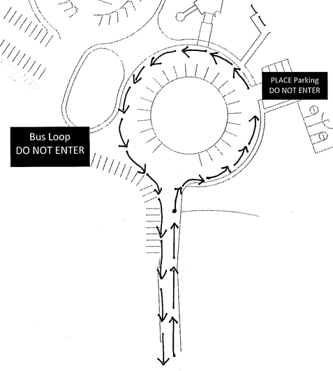
5. For PM dismissal, please make sure your car rider pass is visible through the front window.
Staff Parking
DO NOT ENTER

