Cypress Elementary Adopt-A-Class
Community Partners in Education

About our School
Cypress Elementary opened in 1973 and is currently home to over 600 students. Cypress is a progressive, learning community-oriented school which emphasizes cooperation in a positive, creative, enthusiastic and safe environment. The curriculum at Cypress is designed to meet the needs of each individual child as he or she grows physically, academically, emotionally and socially.

Partners
We all want the best for all our children and the dedicated staff at Cypress Elementary can use your help. Your involvement in the Cypress Adopt-A-Class Program will assist our staff with making an impact on the future by providing additional support to the class of your choice.

Adopt-A-Class Program Objectives
- To obtain additional financial support for all classrooms and departments of the school.
- To create an environment where the children and staff at Cypress Elementary recognize that families and the business community are dedicated to our children’s education and future.
- To create an attitude of pride and respect among the children at Cypress Elementary for our families and business community.

Becoming a Partner
For a tax-deductible donation, you can adopt a class or special area of our school and become a partner in education. Your Adopt-A-Class Program donation will be used to provide such items as computer software, books, learning materials and supplies. All departments of the school would benefit from your assistance and support.

Family Adoptions are available for families who would like to make a tax-free donation of $100 or more to a classroom or department of their choice. Family Donations will be in the name of the family.

Business Adoptions are for those who would like to make a tax-free donation of $150 or more to a classroom or department of their choice. Business Donations will be in the name of the business.

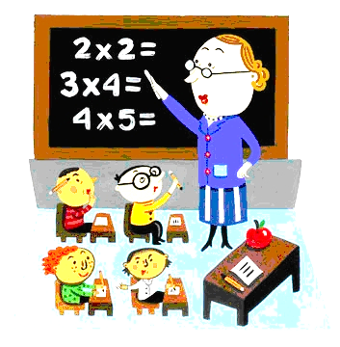
Benefits as a Partner
You will receive the following:
- Recognition displayed in the front office area/foyer.
- Thank you letter from your adopted class.
- Thank you letter from our principal
- Adoption will be posted in three newsletters.
- Adoption will be posted on our marquee for one week.
Adoption will be posted on School Webpage.

Other ways to become a Partner in Education
- Serve as a guest speaker during the Great American Teach-In.
- Join our Banner program!
- Assist in recognizing students who have made improvements in academics, attendance, or behavior.
- Challenge colleagues and competitors to Adopt-A-Class.
- Assist in providing student incentives.

Cypress Elementary Adopt-A-Class Corrdinator
Debbie Hemby 727-774-4500 dburd@pasco.k12.fl.us

-----------------------------------------------------------------------------------------

I would like more information on the Adopt-A-Class Program

____Please send an application for a family/business adoption home with my child.
____Please send me an electronic application for a family/business adoption to

____My email address _________________________.
____Please call me at __________________.

Name _________________________________ Student_____________________________

Tear off and return to front office

