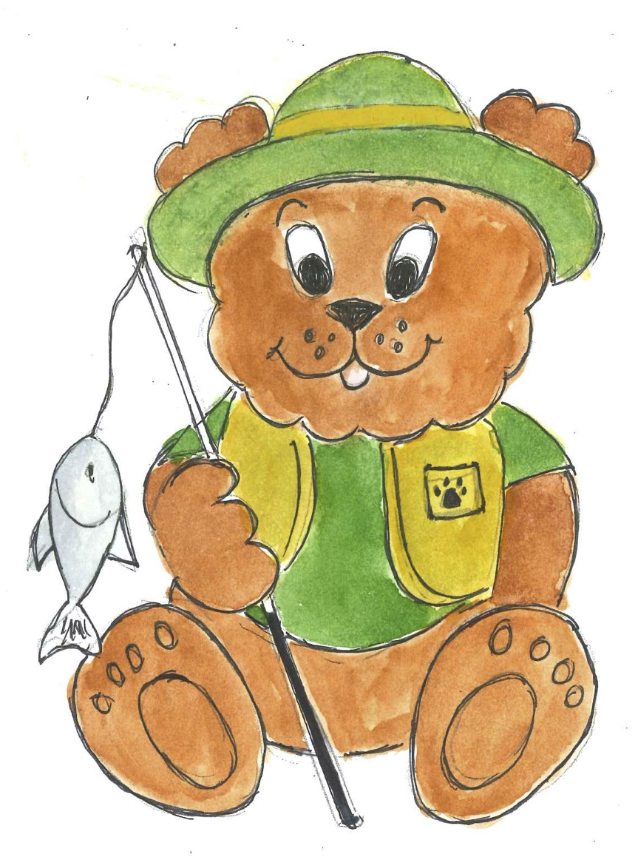
Cypress Elementary School

10055 Sweet Bay Court, New Port Richey, FL 34654
727-774-4500 Phone 727-774-4591 Fax ces.pasco.k12.fl.us

Jeanne Krapfl, Principal
Erika Tonello, Assistant Principal

Dear 5th Grade Families, 9-20-22

After a couple of tough Pandemic years, we are working hard to ensure every student grows in their learning this year at Cypress! Our teachers are collaboratively planning State Standards, using our State adopted curriculum, and providing interventions to those students who are struggling with previous skills needed to be successful in 5th grade.
With that said, we have found that the current 5th graders are losing instructional minutes when they transition between two teachers for different subjects. The 5th grade team met and have decided that they are going to go back to a traditional day of one teacher teaching all subjects with the same students all year. This will allow each teacher to create that classroom community of respect and build relationships that supports every learner. This will also help families to build that personal connection with your child’s teacher. The teachers will be working on all the logistics this week and we will transition back to a traditional teaching model on Monday September 26th. Thank you for your support and we appreciate your understanding as we work to maximize student growth in every 5th grade classroom.

Jeanne L. Krapfl
Principal Cypress Elementary
jkrapfl@pasco.k12.fl.us
727-774-4500
ces.pasco.k12.fl.us
Strengths: Harmony, Achiever, Developer, Input, Learner

